Project Design Phase Solution Architecture
Data Science Project Documentation
Submitted By: Chukka Reddy Anusha, Roja | Date: 15 July 2026

Problem – Solution Fit Template

Team | Edralla Roja  Reddy Anusha
Project Name | Strategic Product Placement Analysis: Unveiling Sales  Impact with Tableau Visualization

Problem – Solution Fit
Retail stores often struggle to understand how product placement (eye-level shelves, end caps, checkout counters, aisle positioning) impacts sales performance. Decisions about placement are frequently based on assumptions rather than data, leading to:

Purpose
- To analyze the impact of product placement on overall sales performance.
- To identify high-performing shelf positions such as eye-level, end caps, and checkout areas.
- To use Tableau for creating interactive dashboards and visual reports.
- To compare sales performance before and after placement changes.
- To optimize store layout for better space utilization and higher revenue.
- To support data-driven decision-making in retail management.
- To improve visibility of high-margin and promotional products.
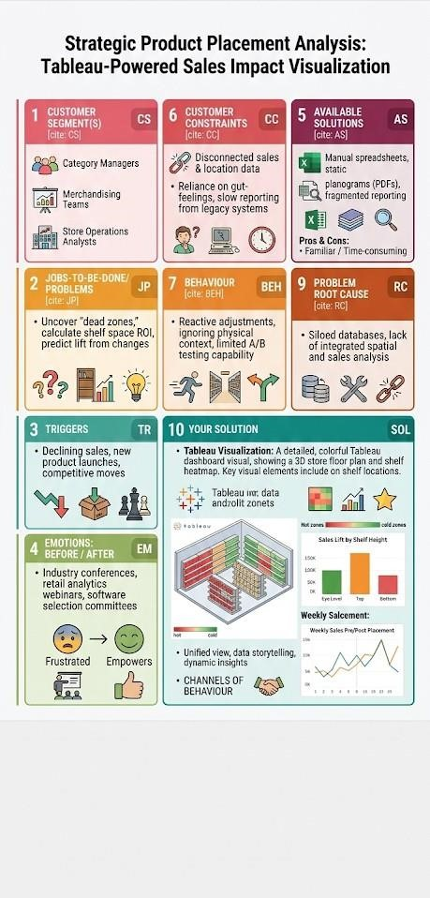
- To enhance overall profitability through strategic product positioning.

